Name: _________________________________________ Class: ____
2025 TERM ONE MZIMBA NORTH DISTRICT EXAMINATIONS

GEOGRAPHY FORM 4

Subject Number: M073/II
Monday, 15 December, 2025 Time Allowed: 2 hours (1:00 -3:00am)

PAPER II
(100 marks)
INSTRUCTIONS

- This paper contains 9 printed pages, please check.
- This paper has two sections, A and B. Answer all the questions in the spaces provided.
- Write your name and stream on all pages.
- In the table provided on this page, tick against the question number you have answered.
- At the end of the examination, hand in your paper to the invigilator.

Question  Number | Tick if  answered | Do not write in  these columns
1
2
3
4
5
Total

©mzn-t1-2025

Section A (75 marks)
Answer all questions
- a. Study Figure 1 below showing a diagram of oil extraction. Use it to answer questions that follow.
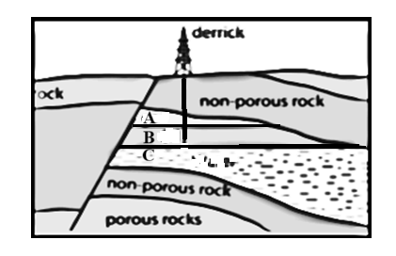
(i) What type of mining is taking place in the figure above?
_______________________________________________________________________ (1 mark)
(ii) Identify the part labelled A in the diagram above. ________________________________________________________________________ (1 mark)
(iii) Explain how oil is extracted using the diagram shown in the Figure above.
______________________________________________________________________________________________________________________________________________________________________________________________________________________________________________________________________________________________________________________________________________________________________________________________________________________________________________________________________________________________(5 marks)

(iv). Give any two negative effects of oil extraction on the environment.
_______________________________________________________________________________________________________________________________________________________ (2 marks)
b. Give any two member nations of the Organization of Petroleum Exporting Countries in Africa.
_______________________________________________________________________________________________________________________________________________________ (2 marks)

c. (i) With the aid of a well-labelled diagram describe how hydro-electrical power is generated.

_______________________________________________________________________________________________________________________________________________________________________________________________________________________________________________________________________________________________________________________________________________________________________________________________________________________________________________________________________________________(6 marks)
(ii) What are the two advantages of solar power?
_______________________________________________________________________________________________________________________________________________________ (2 marks)
d. (i) Explain any two positive effects of energy crisis in Malawi.
_______________________________________________________________________________________________________________________________________________________________________________________________________________________________________________________________________________________________________________________ (4 marks)
(ii) Why does Malawi not venture into nuclear energy production? _______________________________________________________________________________________________________________________________________________________ (2 marks)

- a. Figure 2 is a world map showing major fishing grounds. Use it to answer the questions that follow.
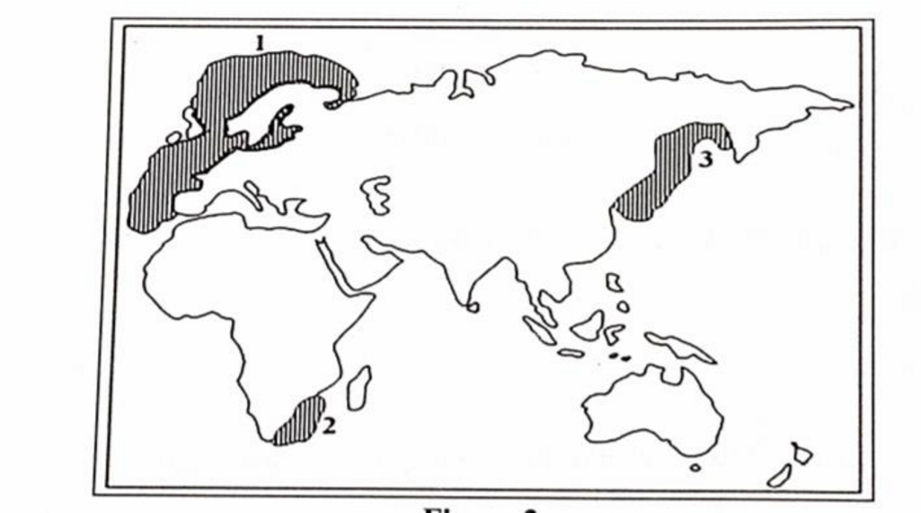
Figure 3
(i) Name the fishing grounds marked 1 and 2.
1: _______________________________________________________________
2: _______________________________________________________________(2 marks)
(ii) Explain any two factors that influence the development of fishing ground marked 1.
__________________________________________________________________
__________________________________________________________________
__________________________________________________________________
__________________________________________________________________
(4 marks)
(iii) Give any two examples of fish caught at fishing ground marked 3.
__________________________________________________________________
_________________________________________________________________ (2 marks)

- (i) Explain any two effects of poor waste disposal on the following:
1. Atmosphere
____________________________________________________________
____________________________________________________________
___________________________________________________________ (2 marks)
2. Economy
____________________________________________________________
____________________________________________________________
___________________________________________________________ (2 marks)
(ii) Give any two ways in which waste management is important __________________________________________________________________
__________________________________________________________________
_________________________________________________________________ (2 marks)

(iii) Give any three economic importance of wildlife in Malawi.
__________________________________________________________________
__________________________________________________________________
_________________________________________________________________ (3 marks)

- (i). Define the term Counter-urbanization.
_________________________________________________________________(2 mark)
(ii). Explain the influence of the following factors on urbanization;
1. Industrialization
___________________________________________________________________________________________________________________________________________ (2 marks)
2. High birth rate
___________________________________________________________________________________________________________________________________________ (2 marks)
- a (i). Mention any three problems associated with urbanization.
_____________________________________________________________________________________________________________________________________________________________________________________________________________________ (3 marks)
(ii) Explain the process of recycling as a method of managing wastes.
___________________________________________________________________________________________________________________________________________ (2 marks)

(iii) Mention any two advantages of recycling.
_____________________________________________________________________
________________________________________________________________ (2 marks)
(b) Figure 3 below is the waste management hierarchy
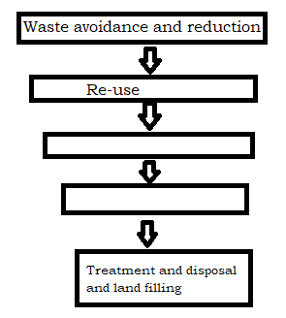
(i) Complete the diagram (2 marks)

(ii) Define the term waste Management hierarchy
____________________________________________________________________________________________________________________________________________ (2 mark)

(iii) Which level is the most desirable waste management method and why?
_____________________________________________________________________________________________________________________________________________________________________________________________________________________ (3 marks)
c. (i) Define the term wetland
___________________________________________________________________________________________________________________________________________ (2 mark )

(ii). Draw the Map of Malawi and on it show any three wetlands.
 (5 marks)
(iii) In what one way can wetlands improve water quality for domestic use by downstream users?
_______________________________________________________________________________________________________________________________________________________________________________________________________________________________________________________________________________________________(2 marks)
- (i) What is carbon sequestration?
___________________________________________________________________________________________________________________________________________ (2marks)

(ii) Mention any three endangered species in Malawi.
_____________________________________________________________________________________________________________________________________________________________________________________________________________________ (3 marks)

SECTION B (25 marks)
Answer one question only.
- a. Study Figure 4 below showing a map of Africa and answer questions that follow.

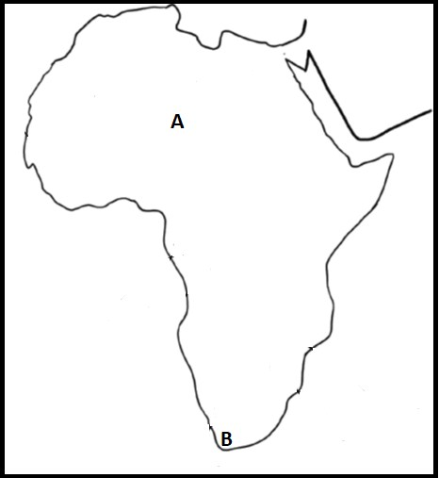
(i) Which letter represents each of the following?
1. Densely populated region
_______________________________________________________________ (1 mark)
2. Sparsely populated region
______________________________________________________________(1 mark)
(ii) Describe any two factors for the population density at A.
___________________________________________________________________________________________________________________________________________________________________________________________________________________________________________________________________________________________________________(4 marks)
(iii) Give any two negative effects of rapid population growth on development.
__________________________________________________________________________________________________________________________________________________(2 marks)

Study Figure 5 below showing population structures of Country A and Country B and answer questions that follow.
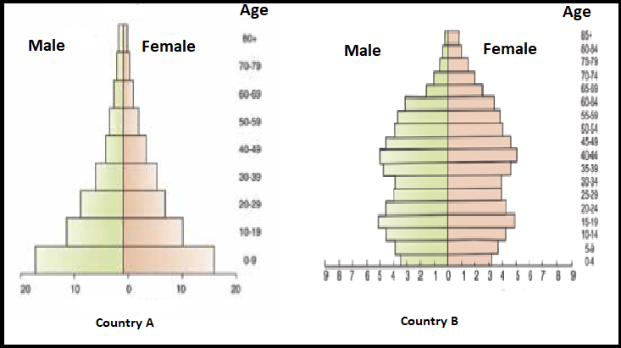
b. (i) Why does Country A have a wide base?
__________________________________________________________________________________________________________________________________________________ (1 mark)
(ii) Explain why Country B has a narrow base.
__________________________________________________________________________________________________________________________________________________ (1 mark)
(iii) Between the two countries, A and B, which one has a low dependency ratio?
_____________________________________________________________________ (1 mark)
(iv) Give a reason for your answer 4.b.(iii).
__________________________________________________________________________________________________________________________________________________ (2 marks)
(v) Explain the economic implication for Country A with such population structure?
________________________________________________________________________________________________________________________________________________ (2marks)
c. Describe two points on the following stages of the Demographic Transitional Model:
1. Stage Two or Early expansion stage
__________________________________________________________________________________________________________________________________________________ (2 marks)
2. Stage Four or Low stationary stage
__________________________________________________________________________________________________________________________________________________ (2 marks)
(d) i. Give any two causes of rapid population growth in Malawi.
___________________________________________________________________________________________________________________________________________(2 marks)
(ii) Describe any two factors for rapid growth of Lilongwe city ________________________________________________________________________________________________________________________________________________________(4marks)
5. a. (i) Define the term “dependency ratio.”
_________________________________________________________________
_________________________________________________________________ (2 mark)
(ii) If the number of the economically active population of country X is 45 000 000 while that of
the non-economically active population is 9 000 000.
1. Calculate the country X’s dependency ratio.

(2 marks)
2. Interpret the dependency ratio for country X.
_______________________________________________________________
_______________________________________________________________
_______________________________________________________________
_______________________________________________________________ (3 marks)
  - Explain any three disadvantages of a youthful population.
________________________________________________________________________
________________________________________________________________________
________________________________________________________________________ ________________________________________________________________________ ________________________________________________________________________(6 marks)
  - (i) Define the term “urbanization.”
__________________________________________________________________
__________________________________________________________________ (2 mark)
(ii) Explain any two disadvantages of rural – urban migration for the rural areas.
__________________________________________________________________
__________________________________________________________________
__________________________________________________________________
_________________________________________________________________(4 marks)
d (i). Define the term remote sensing.
_________________________________________________________________
_________________________________________________________________(2 marks)
(ii) How is remote sensing and geographic Information System applied in the following fields;
1. Transportation
___________________________________________________________________________________________________________________________________________(2 marks)
2. Epidemiology
_________________________________________________________________________
_________________________________________________________________ (2 marks)
END OF QUESTION PAPER
NB. This paper contains 9 printed pages

